 

INSTITUTE FOR ADVANCED COMPUTING AND SOFTWARE DEVELOPMENT AKURDI, PUNE

Documentation On

**“Courier Management System”**

E-DAC SEPT 2021

*Submitted By:*

**Group No: 51**

## Salvi Abhilasha Rajendra 219160

**Jadhav Pragati Maroti 219075**

**Mrs.Shilpa Pawale**

**Mr.Prashant Karhale Mr.Kashinath Patil**

**Centre Coordinator Project Guide**

# Table of Contents

1. Introduction 1
   1. Document Purpose 1
   2. Problem Statement 1
   3. Product Scope 2
   4. Aim and Objectives 2
2. Overall Description 3
   1. Functional and Non-Functional requirement 4
   2. Operating Environment 5
   3. Design and Implementation Constraint 5
3. Requirements Specification 6
   1. External Interface Requirements 6
4. System Diagram 7
   1. Activity Diagram 7
   2. Use Case Diagram 8
   3. ER Diagram………………………………………………………………………………………9
5. Table Structure 10
   1. Admin………… 10
   2. Customer……………………………………………………………………………………......10
   3. Staff…………………………. 10
   4. Parcel and Branch……….. 11
6. Snapshot…………….. 12
   1. Login page………………………………..……………………………………………………..12
   2. Home Page……………………………………………………………………………………...12
   3. Add Staff……………………………………………………………………………………….13
   4. Add Customer………………………………………………………………………………….14
   5. Add Parcel and Branch…………………………………………………………………...........15
   6. Track Parcel…………………………………………………………………………………….17
7. Conclusion…………………………………………………………………………………………...18
8. Future Scope………………………………………………………………………………………...19
9. References…………………………………………………………………………….……………..20

# Introduction

The Courier Management System is a simple java project that helps a courier company or businesses manage their customers' parcels or packages details. The system stores all the information related to parcel, customers, and staff.

The system has a tracking feature where can help to monitor the movement of the customer's parcel. The Admin user can manage all the data in the system including managing the branches and branches staff user. The Customer can only track a parcel.

While taking orders from its customers, the Admin will take all the details of its customers who is placing the orders and all the details for the recipient such as its address, name, mobile number etc.

The couriered items have multiple statuses which are the "Item Accepted by Courier", "Collected", "Shipped", "In-Transit", "Arrived At Destination", "Out for Delivery", "Delivered" and "Unsuccessful Delivery Attempt". These statuses will help to determine the movement of the parcel. The system also generates a report between two dates and selected status.

The system admin can store or adds multiple items at the same time but these items will be stored in the database separately because each package has a different reference number or different tracking number. For example, Client 1 has 3 boxes of the package to be couriered in the same recipient, the system user can submit the parcel registration to the system at once but will be stored separately so that the system will generate a different unique reference number in each item so that they can track easily each item.

### Document Purpose

The Courier management system is web application that helps a courier company or businesses manage their customers' parcels or packages details. The system stores all the information related to parcel, customers, and staff. The system has a tracking feature which can help to monitor the movement of the customer's parcel. The Staff user can manage all the data in the system including managing the branches and staff user. The Customer can only track a parcel.

### 1.2 Problem Statement

### The Organization was holding the system where the records in the database were not completely secure. In the current system, where whole records were handled by various employees and the data were stored in registers and excel sheets. This results in data redundancy.

### 1.3 Product Scope

# It manages all the information about courier, Customer, Employees.

# Status will get updated for each parcel.

# For Each parcel different tracking number will be generated.

# It will provide report on courier based upon Status.

# After adding parcel details a mail is sent to the customer regarding the tracking number and a link to track parcel.

# Customer can track their parcel using Tracking number generated for each parcel.

### 1.4 Aims and Objectives

Specific goals are: -

# To produce a web-based system that allows the admin to manage the Courier management system.

# To provide security to the records in the database

# To generate the multiple reports form the information provided as per requirement.

# To ease the process of courier company.

# 2. Overall Description

### 2.1 Functional and Non-Functional requirements

### Functional Requirements:

# Login:

# Admin can login using some credentials such as registered email id and password.

# Dashboard:

# Admin can view numbers like total number of customer, total number of parcels, total number of staff, how many parcels are accepted or in-transit, shipped, out of delivery or delivered or unsuccessful delivery.

# Parcel details and branch detail:

Admin will add customer and parcel details.Admin also add branch details.Preview of parcel details will be generated and a mail is sent it to the customer on their registered email id regarding tracking number and track parcel link.

# Parcel tracking:

# Customer will be able to track parcel status. Customer will be able to track deliver using unique tracking id send to them through mail. Admin will be able to track parcel delivery for particular customer.

# Parcel status:

# Admin will update the status of Parcel.

# Delivery processing:

# Admin will add customer detail and parcel details and then he assign branch for that parcel. Then he also update tracking status of customer.

# Parcel list and branch list:

# Admin can view information related to parcel and branch which is stored in the database.

# Staff list:

# Admin can view information related to staff which is stored in database.

# Customer list:

# Admin can view information related to customer which is stored in database and can edit the information of customer and also it can delete it. Admin can add parcel from list. It will redirect to add parcel page where the details of customer is fetched and admin has to add recipient information.

# Add Customer:

# Admin can add information of customer and if customer is registered already so it will give a message that email id is already exists.

### Non-Functional Requirements:

# Security

Admin will be allowed to place the courier order for customer. System will internally maintain secure communication channel between Servers (App Servers, database Server). Sensitive data will be always encrypted across communication. Use of proper firewall to protect servers from outside fishing, vulnerable attacks.

# Reliability

The system will backup business data on regular basis and recover in short time duration to keep system operational. Continuous updates are maintained, continuous Administration is done to keep system operational.

# Availability

System will be available for 24/7.

# 

# Maintainability:

Commercial database software will be used to maintain System data Persistence. Admin will easily monitor and configure System using administrative tools.

# Portability:

PDA: Portable Device Application.System will provide portable User Interface (HTML, CSS, JS) through staff will be able to access courier management system.

# Accessibility:

Only registered staff will be able to place an order of consignment after authentication. Staff team will be able to view daily, weekly, monthly, annual all the information of delivery person, customer, and consignment information through customized dashboard. Staff will be able to see the delivered product graph.

# Safety:

CMS will be secure from malicious attack, fishing. CMS will be always kept updated with latest anti-virus software and kept it updated.

# Modularity:

System will be designed and developed using reusable, independent or dependent business scenarios in the form of modules. These modules will be loosely coupled and highly cohesive. System will contain adding consignment details, updating status, tracking, delivery processing and consignment list.

### 

### 2.2 Operating Environment:

# 2.2.1 Hardware Specifications:

**Processor** - Any Processor above 1 GH

**RAM** - Minimum 4GB.

**Hard Disk** - Minimum 500 GB

# 2.2.2 Software Specifications:

**Front End** - ReactJS

**Back-End** - Spring-boot.

**Database** – MySQL.

**Software** – Spring Tools Suite STS.

**Operating System** - Windows Family.

### Design and Implementation Constraints:

* The application will use Reactjs, mysql and Springboot as main technologies.
* HTTP protocol are used as communication protocols. the client can access it via HTTP protocol.
* Several types of validations make this web application a secured.
* Since Courier Management System is a web-based application, internet connection must be established.
* The Courier Management System will be used on PCs and will function via internet or intranet in any web browser.

# 3. Requirement Specification

### 3.1 External Interface Requirements:

**User Interfaces:**

**Admin**

* Dashboard
* Add customer and parcel details.
* Add branch details.
* Update Parcel status..
* Parcel List.
* Customer List.
* Staff List and branch list.
* Track Parcel.
* Report.

**Customer**

* Track Parcel.

**Hardware Interfaces:**

* + No extra hardware interfaces are needed.
  + The system will use the standard hardware and data communication resources.

# 4. System Design

### 4.1 Activity Diagram

This is Activity UML diagram of Courier Management System which shows the flow of Admin module.

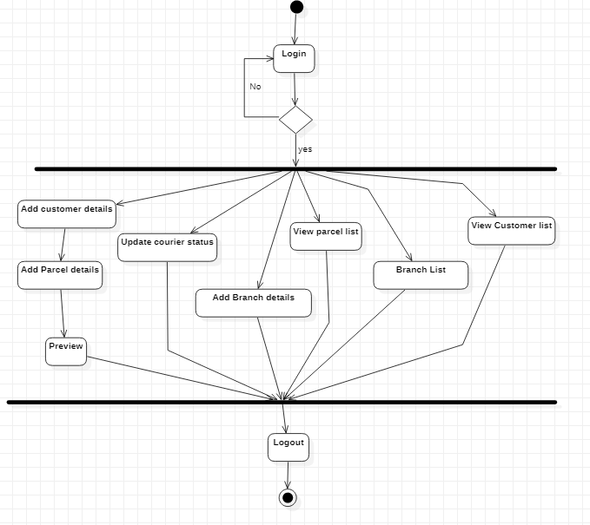

**Figure 1: Activity Diagram**

### 4.2 Use Case Diagram

This use case Diagram is a graphical depiction of the interactions among the elements of Courier Management System. It represents the methodology used in the system analysis to identify, clarify and organize system requirements of Courier Management System. The main actors of Courier Management System in this Use Case Diagram are: Admin, Staff and Customer who perform the different types of use cases shown on the picture below.

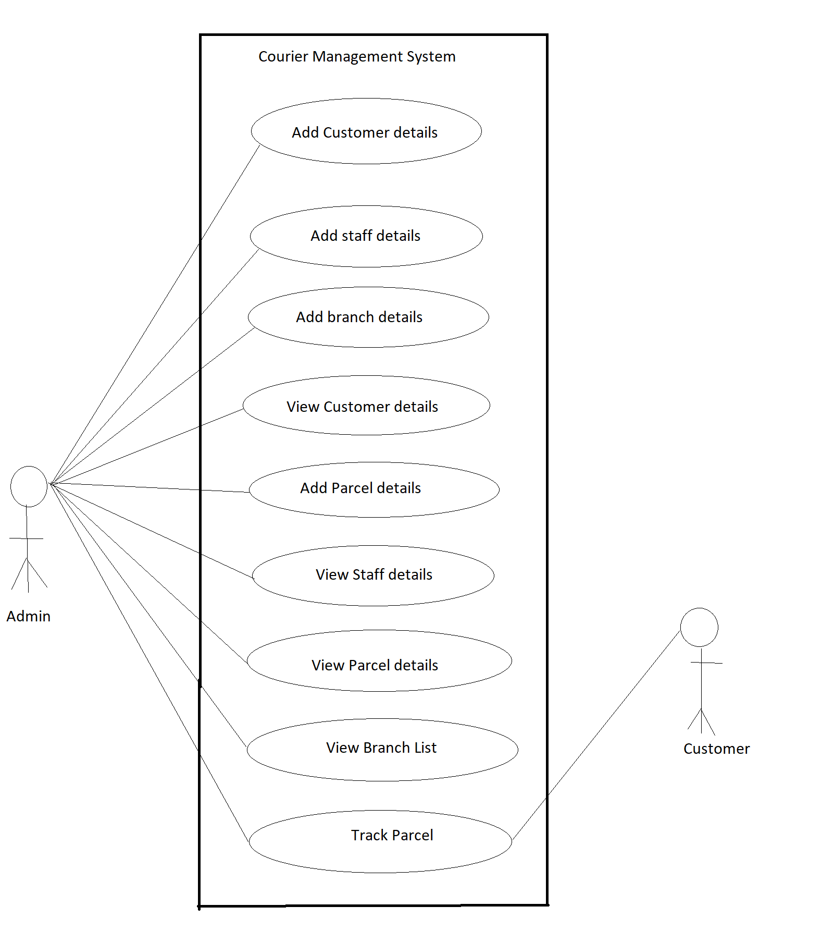

**Figure 2: Use Case Diagram**

### 4.3 ER Diagram

This ER (Entity Relationship) Diagram represents the model of Courier Management System Entity. The entity-relationship diagram of Courier Management System shows all the visual instrument of database tables and the relations between Admin, Staff, Parcel details and Customer etc. It used structure data and to define the relationship between structured data groups of Courier Management System functionalities.

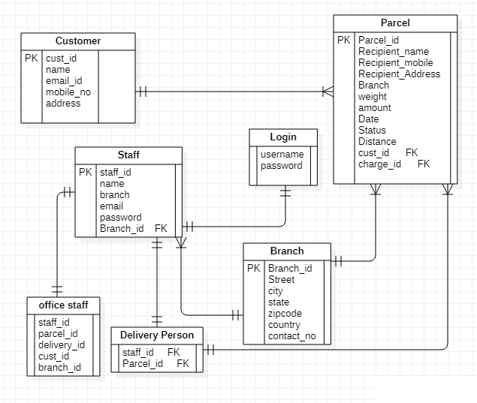

**Figure 3: ER Diagram**

# 5. Table Structure

### Admin:

### 

### Customer:

### 

### Staff:

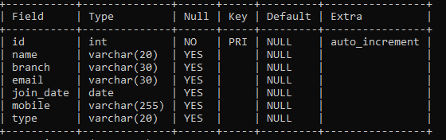

### Parcel:

### 

### 5.5 Branch:

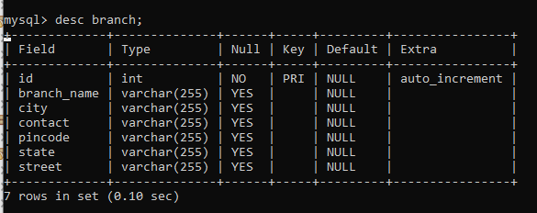

# 6. Snapshots

**6.1 Login Page**

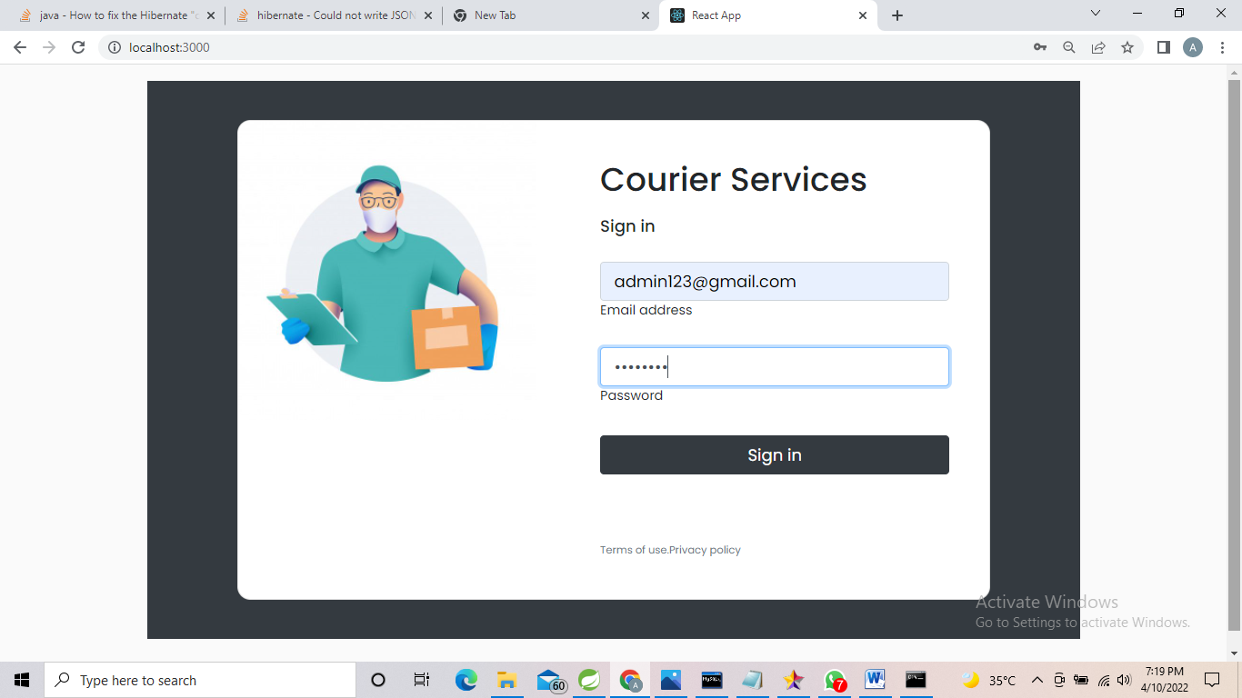

* 1. **Homepage**

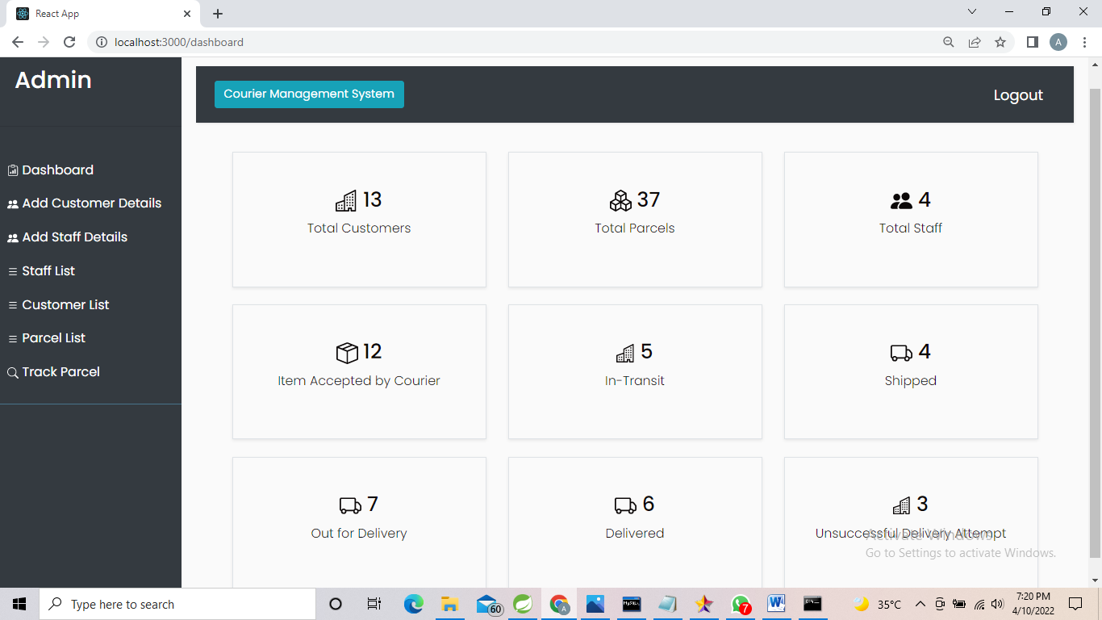

**6.3 Add Staff**

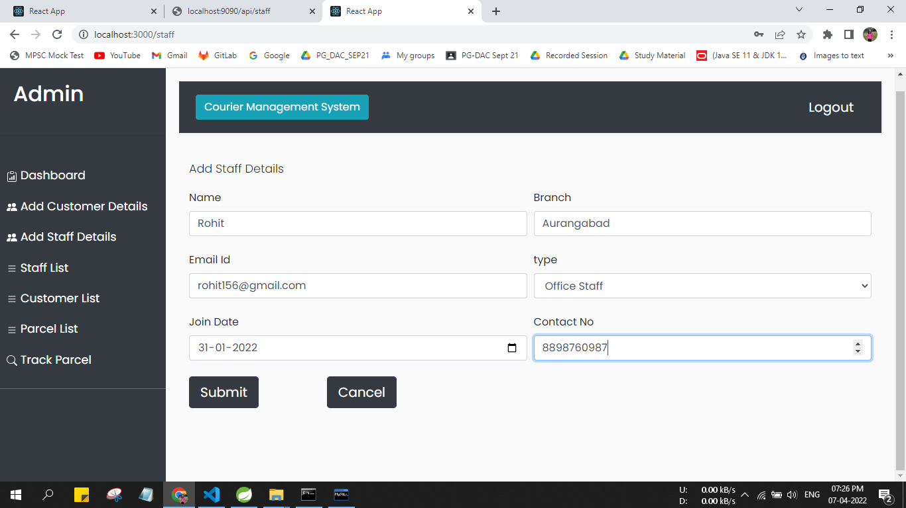

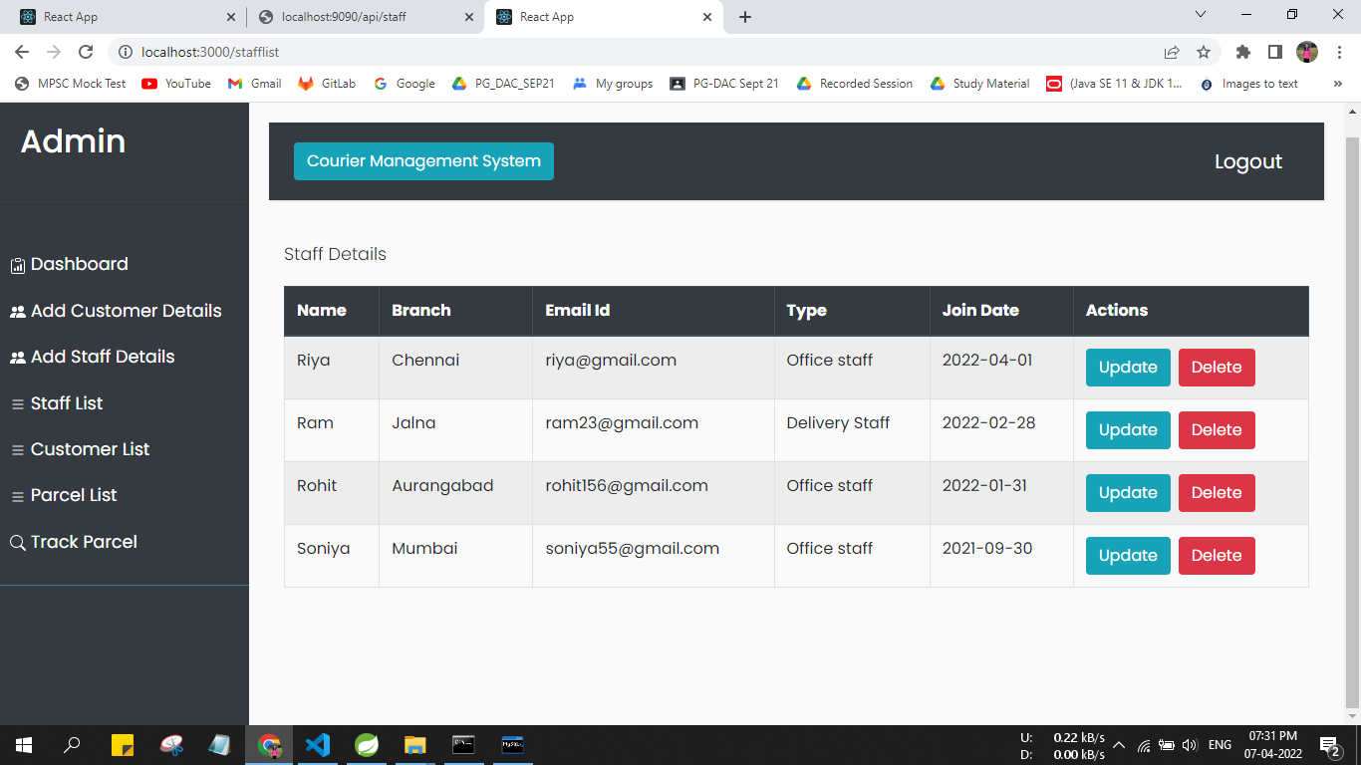

**6.4** **Add Customer:**

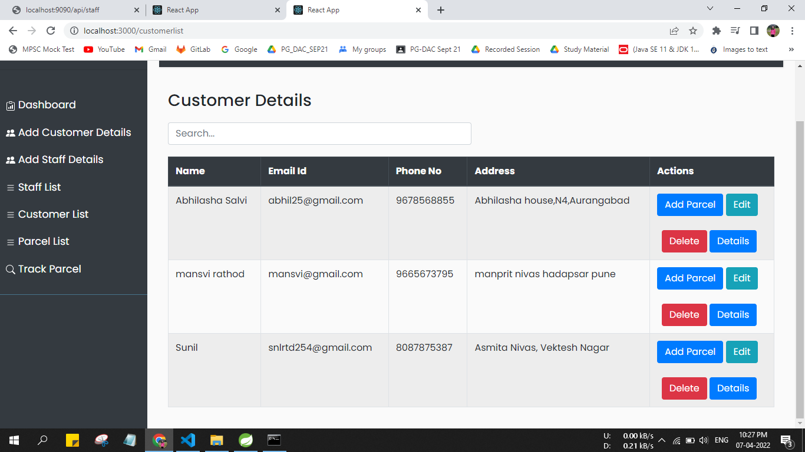

**6.5 Add Parcel:**

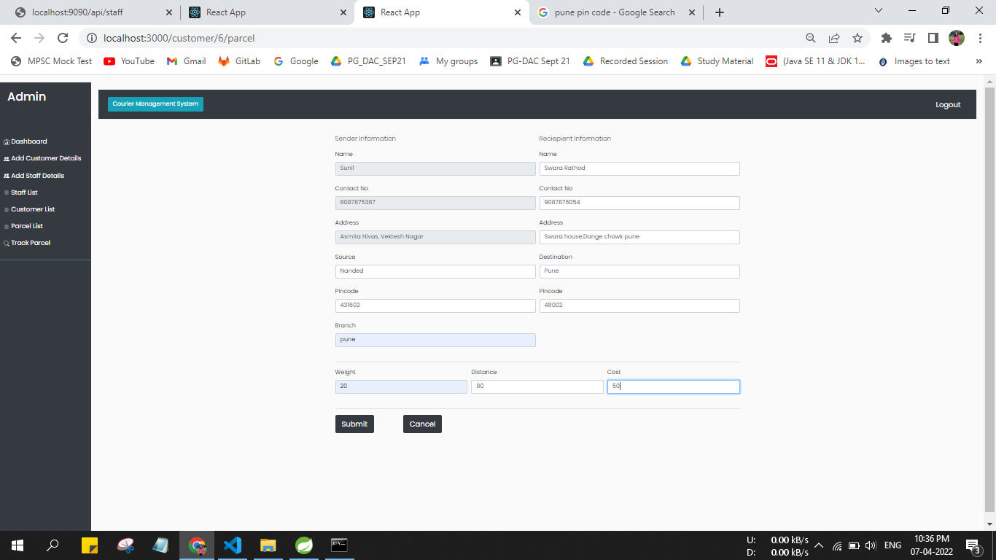

**Parcel List:**

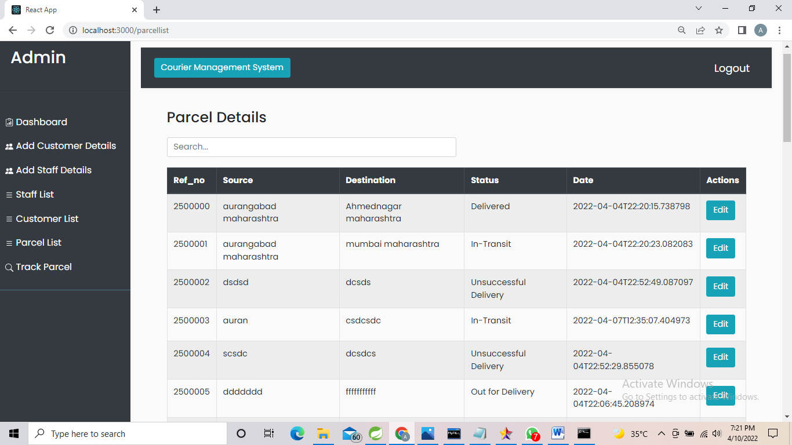

**Update Status:**

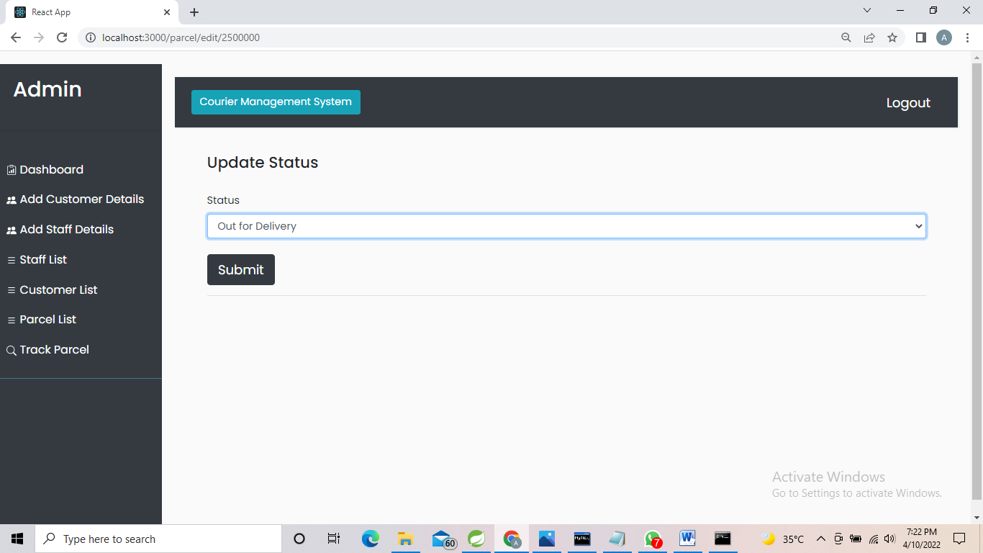

**Add branch details:**

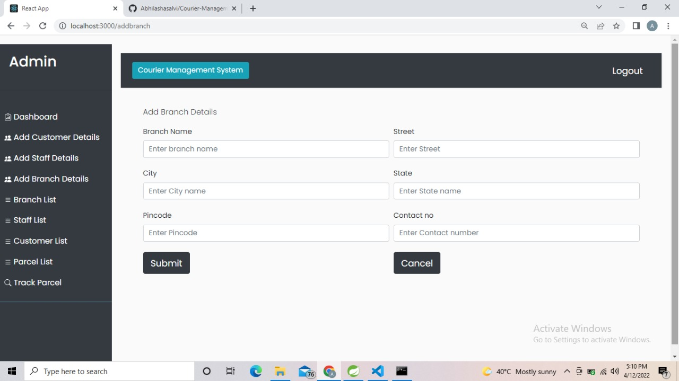

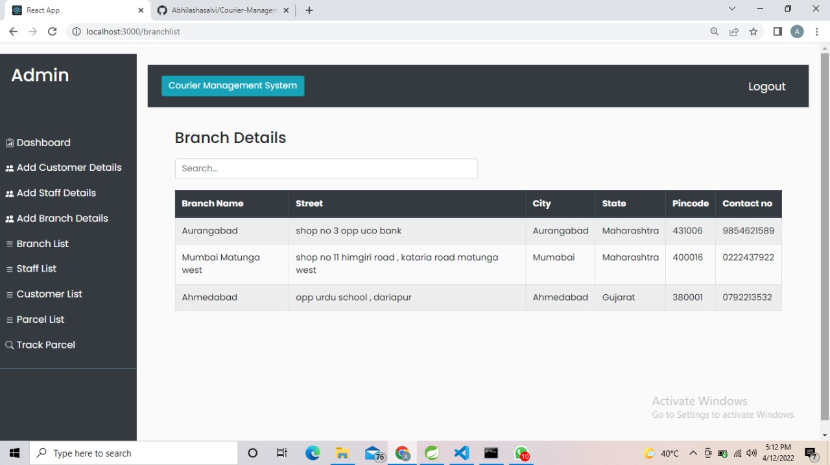

**6.6 Track Parcel:**

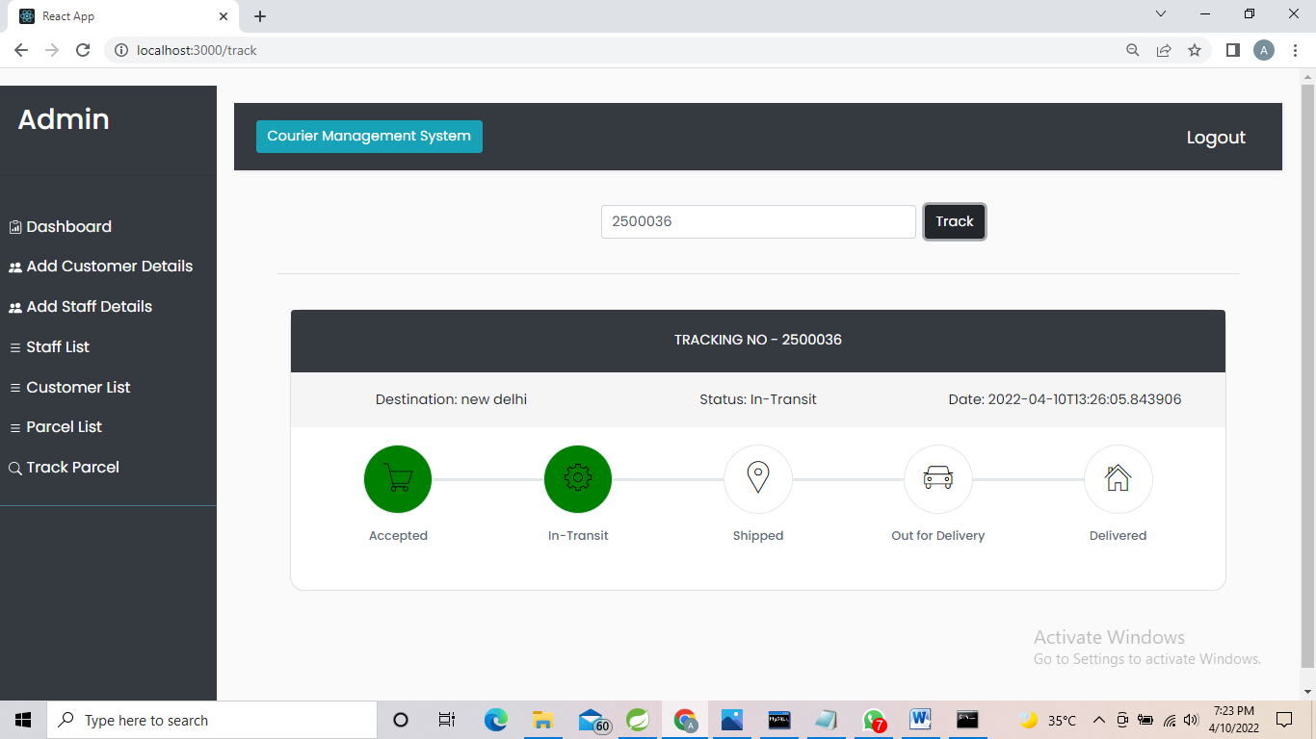

Mail is sent to customer:

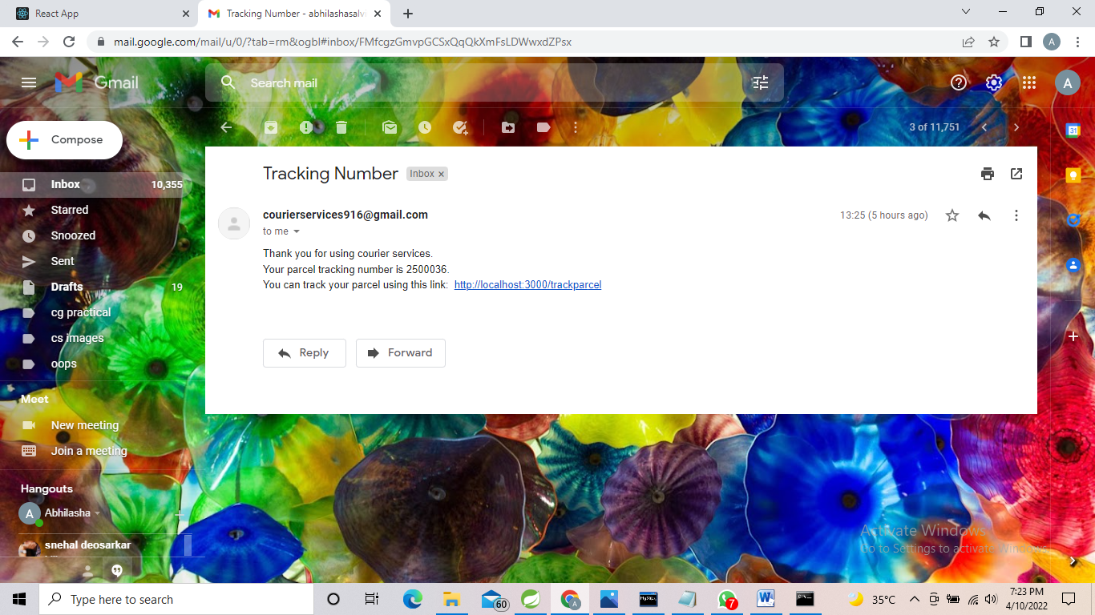

**7. Conclusion**

Using this project “Courier Management System” reduced as much as possible to avoid errors while entering the data. It also provides error message while entering invalid data. No formal knowledge is needed for the user to use this system.

Courier Management System, as described above, can lead to error free, secure, reliable and fast management system. It can assist the user to concentrate on their other activities rather to concentrate on the record keeping. Thus, it will help organization in better utilization of resources.

**8. Future Scope**

* We can give more advance software for Courier Management System including more facilities.
* Customer can online book for parcel pickup.
* We will host the platform on online servers to make it accessible worldwide.
* Implement the backup mechanism for taking backup of codebase and database on regular basis on different servers.

**9. References:**

* Google for problem solving
* http://www.javatpoint.com/java-tutorial
* http://www.tutorialspoint.com/mysql/
* httpd.apache.org/docs/2.0/misc/tutorials.html
* Head First Java 2nd Edition
* https://www.bezkoder.com/jpa-one-to-many/